
KIST COLLEGE OF MANAGEMENT
Full Marks: 60
Pass Marks: 36
Time: 3 hrs.
Affiliated to Tribhuvan University
Kamalpokhari, Kathmandu
August, 2023
Pre - Board Examination
BIM / Third Semester/ IT 237: Web Technology I

Candidates are required to answer the question in their own words as far as practicable.

Group – A
Brief Answer Questions: [10 x 1 = 10]
- What is DNS?
- Define AJAX and JSON.
- write a source code to create an image as a link.
- What do you mean by HTML events?
- Why is the use of CSS?
- Define class and object.
- Define responsive web design.
- What is jQuery?
- Why do we need scripting language?
- Why do we need form validation?

Group – B
Short Answer Questions (Attempt Any Five Questions): [5 x 3 = 15]
11. Explain HTTP request message in brief.
12. Explain structure of an HTML file with example.
13. Write a source code to demonstrate nested table.
14. How do you handle errors in JavaScript.
15. Explain various sectioning elements of HTML5.
16. Explain client-server architecture.

Group – C
Long Answer Questions (Attempt Any Three Questions): [3 x 5 = 15]
- write code to display the following form.

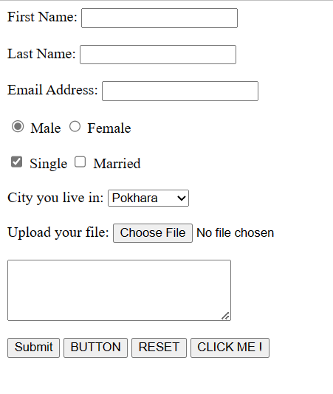

18. What is CSS box model? Create a box model that wraps around <div> tag with
margins, borders, padding, and actual content.
19. Define cookies. How do you set cookie value in JavaScript?
20. Write a JavaScript function that takes two strings as arguments and checks them for equality. If both the strings are equal then display the first string in uppercase else return “the two strings do not match”.

Group – D
Comprehensive Answer Questions: [2 x 10 = 20]
- Explain different ways of inserting CSS in an HTML document? Explain different type of selector with example.
22.Create an HTML form with fields username, password, and country. The username field should be textbox type, password field should be password type, and the country should be a drop-down list. Now write a JavaScript function to validate this form. The function should validate the username to be of length 8, password should start with digit and should be alphanumeric, and the country field should be selected.

*****

